

Mapping Food Insecurity in the Royal Borough of Kingston- Upon-Thames

Background
The Royal Borough of Kingston-Upon-Thames submitted a successful application for a Good Food Retail grant of £5k in March 2020.

The vision is to improve the uptake of Healthy Start vouchers in the borough and to improve access to healthier options, including fresh fruit and veg. The borough has asked Rice Marketing to support them with the first two stages of the vision plan:
- Produce a food desert map using the methodology set by other boroughs to identify areas of the borough where access to healthy, affordable food may be more difficult due to there being no supermarket chains offering competitive prices in the area.
- Highlight strategically important convenience stores that serve as the primary store for low-income families and engage them to stock Healthy Start vouchers as well as healthier options in-store.

Rice Marketing are retail and local experts who work with London boroughs to develop Good Food Retail Plans. These include Southwark, Greenwich and formally Tower Hamlets, all of whom have been identified by Sustain as setting a leadership example through our work. We are experts in understanding target areas in the borough, identifying strategically important convenience stores and then working with them to improve the healthier options in-store.

Mapping
We started by creating a food access map of Kingston in QGIS, including:
- A 'supermarket catchment area' (in blue on the map). Households within this area are maximum 6 minute walking distance away from a supermarket - roughly 500m at an average walking pace of 5km/h.
- We reviewed the food provision from the two street markets in the borough Monday Market and the Ancient Market. We excluded Monday Market as it is only open 1 day per week and we excluded Ancient Market as it predominantly sells street food/high end groceries.
- 2019 Indices of Multiple Deprivation rank data (quintiles) at Lower Super Output Area level for Kingston (the darker colour indicates the most deprived areas).
- Food retail location data from Kingston Food Safety Team, cleaned and matched with Healthy Start registrations.
- Kingston-owned housing estate data from Kingston RBK Valuers team.
- Ward boundaries.
- We added Children’s Centre and Food Bank locations to our map.

For full information about sources and mapping, please see appendices.

From this mapping, we identified potential food-insecure areas to sample, based on the following specification:
- Areas which are more deprived (darker on the map)
- Areas which are outside the supermarket catchment area (shown in blue areas on the map)
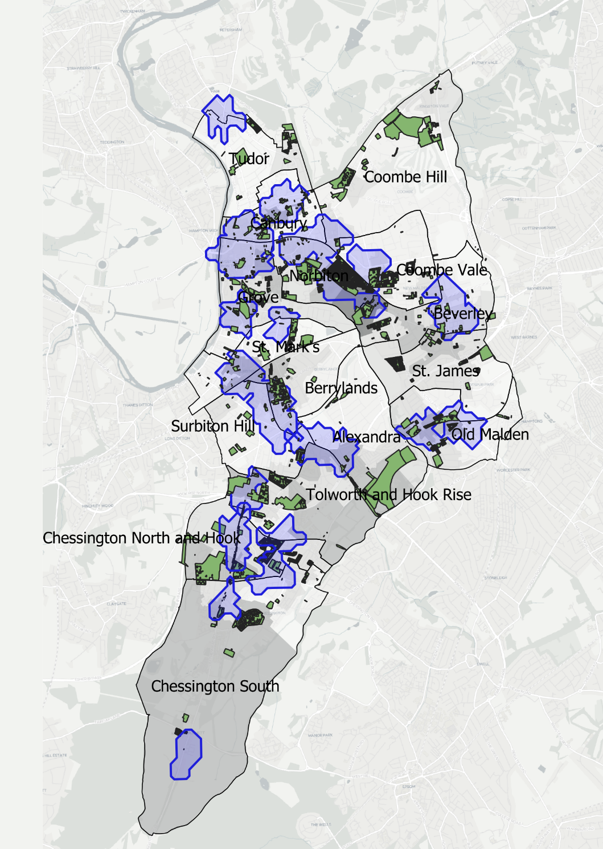
- Areas of Kingston-owned housing (shown in green)

We spoke with local food insecurity expert, Brenda Wood.
She advised that the following areas were areas of concern in her opinion
- Cambridge Road estate
- Garrison Lane, Chessington
- Alpha Road Estate, Surbiton
- Kings Nympton Estate, Kingston Hill
- Malden Manor
This is supported by the mapping data.
We then identified stores within the target areas where intervention could have the maximum impact and some brief desk research was completed on these businesses to ensure the data was up-to-date and the shops were relevant to the study. We also reviewed the current FSA rating of the stores as a rating of 3 stars or above is a criterion for inclusion in the project.
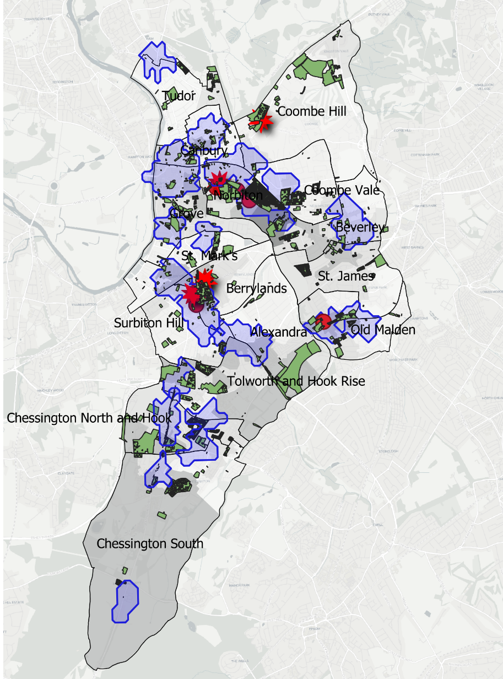

This generated a short list of stores that were checked physically to ensure that they are suitable and we have identified 3 areas to focus on, specifically
- Cambridge Road estate
- Alpha Road Estate, Surbiton,
- Kings Nympton Estate, Kingston Hill
We have excluded Malden Manor as the only retail options are adjacent to the Coop and thus would not improve availability.
We have excluded Garrison Lane, Chessington as there are no stores in the locality to work with.
We shortlisted stores in the selected areas, identifying a primary target and back-ups (these are shown on the attached map as red stars and purple dots respectively).
The findings of these visits are included in the Appendices.
Once this was complete, we could start the process of engagement.

Store Engagement
The food desert map and the local intelligence from The Children/s Centre manager had identified five stores as being strategically important to the borough. We conducted mystery shop visits on 16th Feb to these stores to assess them for their proximity to high profile estates, lack of food access locally, width of range and services, in-store standards and calibre of owner. The following five stores were approved for support:

We produced a briefing letter with the aim of engaging the retailers to the scheme.

Between 22-25th Feb, we visited each store and met with the owner. We used our experience to pitch the support in a way that would add value to each store. None of the stores were registered for Healthy Start. We agreed action plans with them to promote their healthy offer and to help them register for Healthy Start. We did this by completing the registration on their behalf on our laptops. We then printed off the registration forms and returned to the stores for signature and posted the forms on their behalf.

Londis - The Crescent
Established store for over 20 years. Core grocery, fresh and frozen offer. Good Google reviews and used by The Kings Nympton Estate. The pitch was to help promote the store locally to increase customer footfall and to highlight that there is a good range of healthy option available. The owner had stopped accepting Healthy Start owning to issues with customers who had wanted to spend the vouchers on food and drink outside of the agreed lists. However, when I explained that the spend was increasing, he agreed to re-register.
Action Plan:
Completed the Healthy Start registration. Agreed to link closely with The Children’s Centre. Would work to increase and promote healthier choices as part of phase 2.

Ada Food Centre - Cambridge Road
New store that serves the Cambridge Estate. Large fresh food and grocery offer with a bias towards Turkish ranges but no alcohol or tobacco sold. Owner was unaware of the Healthy Start scheme and wanted to register.
Action Plan:
Completed the Healthy Start registration. Agreed to link closely with The Children’s Centre. Would work to increase and promote healthier choices as part of phase 2.

Hawks Local – Cambridge Road
Recently refitted store with good range of healthier options. Important local store due to Post Office. Owner was unaware of the Healthy Start scheme and wanted to register.
Action Plan:
Completed the Healthy Start registration. Agreed to link closely with The Children’s Centre. Would work to increase and promote healthier choices as part of phase 2.

Surbiton Local - Ewell Road
New owners who are looking for a Symbol Group partner. I was able to introduce them to Londis through my network.
New owners have inherited poor range and standards from previous owner. They were not able to commit to any range changes but were happy to sign up for Healthy Start as they intended to sell all of the core products.
Action Plan:
Completed the Healthy Start registration. Agreed to link closely with The Children’s Centre. Would work to increase and promote healthier choices as part of phase 2.

Londis Berrylands Foodstore – Berrylands Road
A busy store which clearly services the Alpha Estate. Wide range of unhealthy products including 10 bays of alcohol. However, they do stock core range of healthier options. The owner was unaware of Healthy Start but wanted to sign up.
Action Plan:
Completed the Healthy Start registration. Agreed to link closely with The Children’s Centre. Would work to increase and promote healthier choices as part of phase 2.

Learnings
- Always position any health campaign in a way that shows the commercial value to retailers.
- Healthy Start is a marketing channel that allows small stores to redeem vouchers worth £3.10 each. This is a new revenue stream.
- Healthy Start is a footfall driver and encourages families to shop more often and for more items.
- The mapping exercise allowed us to identify strategically important stores. This helped us to engage store owners as they could see that we had done a lot of desk work to find them.
- Convenience store owners are entrepreneurs and welcome any new ideas.
- The increase in value of the Healthy Start vouchers is an ideal opportunity to engage more stores.
- The scheme needs to work harder to promote the value of Healthy Start to customers and to eliminate abuse.
- Convenience stores offer a wide range of core healthy options which could be promoted with visual point of sale.
- The process of signing up is not easy as it requires store owners to print off a form which they then need to sign and post. This is too onerous and puts many people off.

Recommendations :
- Identify the number of Healthy Start vouchers available in each store area to understand the local opportunity.
- Work with the HS team to promote newly registered stores to local families.
- Agree a promotional campaign with each retailer whereby they promote discounts or added value on qualifying lines.
- Check the process with Healthy Start to see how well the retailers are supported. Fill in any gaps with a local comms plan including in-store materials.
- Link each store with their local Children’s Centre to promote the new partnership. Ask for family requests for healthier options locally and work with the retailers to stock them.
- Link with major wholesalers including Londis to set up local marketing support for these strategically important stores.
- Produce in-store material to promote healthier options under a Good Food Retail brand.
- Link market fruit and veg stalls to the five retailers and set up a wholesaler agreement for fresh fruit and veg. Prioritise Tony’s fruit and veg in recognition of his work to promote Healthy Start.
- Establish the network of stores as local health hubs and make them feel important through Council publicity.
- Check the communication to newly signed up retailers to see if it is clear and whether they receive a Healthy Start Comms pack. This will need to be built into any future comms pack produced by The Council.
- Very low awareness of the commercial value of Healthy Start. Consider a local marketing campaign to target other convenience stores in the Borough.

Appendices

Appendix 1: Technical Notes on Mapping
The food access map of Kingston was mapped in QGIS version 3.16 and included data from the following sources:
- The ‘Positron’ base layer from the TravelTime platform plugin.
- A 'supermarket catchment area' using geolytix UK retail point open source data. The green area on the map is made up of the combined 6-min walking travel time around each supermarket or street market, which equates to roughly 500m at an average walking pace of 5km/h. Travel time isochrones measured using TravelTime platform plugin (see information on website for more information about algorithms the platform uses). Travel times measured using the Time Map Simple Algorithm and collated into single layer using Dissolve tool in QGIS.
- A vector layer of 2019 IMD rank data (quintiles) at LSOA level for Kingston (the darker colour indicates the most deprived areas) from ArcGIS Hub.
- Food retail location data from Kingston Food Safety Team including usage codes A07 greengrocers, A08 Grocers, A14 Small/Med Supermarket/Grocer, CO6 Newsagents/Confectioners. This data was cleaned manually using knowledge of retail brands to exclude misallocated usage codes (for example Wicks DIY superstore allocated code A14) and using google street maps to identify those C06 stores with a significant fresh food offer. Additionally we used FSA food rating to identify the A14 small supermarkets showing as exempt from rating and as such cannot be selling food.
- The food retail location data was matched with the Healthy Start voucher website to identify any of the retailers currently accepting HS Vouchers.
- Street market location data, extracted from Kingston website on street trading – parsed postcode locations through postcodes.io to get northings and eastings.
- Kingston-owned housing estate data from RBK Valuers team.
- Ward boundary data from London Datastore.
- Children’s Centre locations extracted from Kingston website – parsed postcode locations through postcodes.io to get northings and eastings.
- Food Bank locations extracted from Kingston website – parsed postcode locations through postcodes.io to get northings and eastings.

Appendix 2: Area Visit Findings
- Cambridge Road estate
  - There are store options on the edge of the estate. ADA Food Centre, Cambridge International, Cambridge Road Spar, and Hawks Local could all make a sound second choice. Thames Super Foods looks to be an option but it is classified as an off license on Kingston database.
  - Check where the primary schools are.
- Garrison Lane, Chessington,
  - Loosely served by Hook Road Londis, Jet Spa, Sainsbury’s Local and Tesco Express in Hook, and Lidl, but none of these stores are in walking distance of the estate.
  - This area does not appear to have any convenience stores to work with.
  - Star Centre for child development
  - There are 2 cut throughs to the estate with a Sainsbury Local on the border.
  - Stores Surbiton Convenience Store, Londis Berrylands, Food Fare (too small) and Ishver News (too small)
- Kings Nympton Estate, Kingston Hill
  - There is 1 convenience store serving the estate. Crescent Express
- Malden Manor, Sheephouse Way
  - This area is served by a Coop. There is a Children’s centre here, Old Malden Children’s Centre
  - 2 potential stores would be Manor Express Londis and Jays Stores

